Processing Purchase Orders:

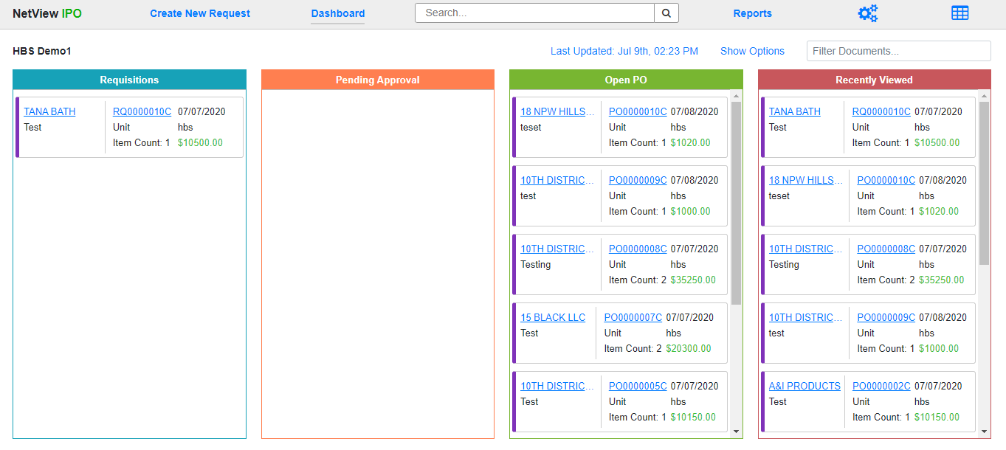

The process of creating, managing, and closing purchase orders in Integrated Purchase Orders (IPO) depends heavily upon which **type** of purchase order (PO) you need to make, as each type requires different information to successfully record the purchase in the system. The following topics will cover the full lifecycle of each PO type, from creation to closing, and detail what steps each IPO user role must take in order to successfully process the order.